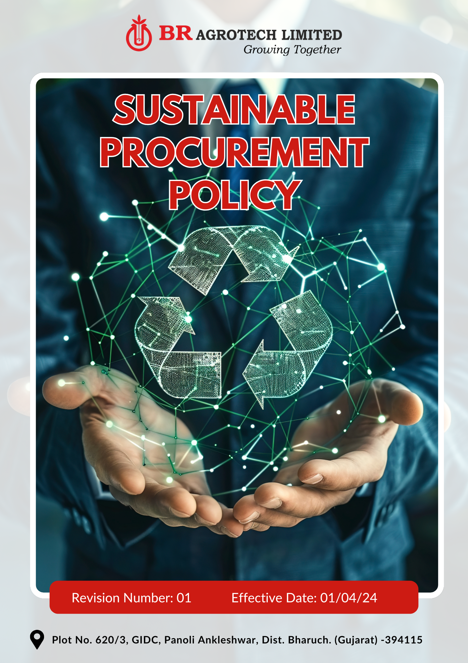

Contents

Preface 3
Policy Declaration 3
Scope 3
Our Commitments 4
Our Performance Targets 4
Alignment with the United Nations Sustainable Development Goals (SDGs) 5
Responsibilities 5
Monitoring, Reporting, and Review Mechanism 6
Employee Acknowledgment Form 7

Preface
BR Agrotech Limited is committed to integrating sustainability into its procurement practices to promote responsible sourcing, environmental stewardship, and ethical labor standards. We recognize that sustainable procurement is vital for minimizing environmental impact, ensuring fair labor conditions, and maintaining business resilience. By collaborating with responsible suppliers and adhering to international best practices, we aim to build a supply chain that upholds sustainability, transparency, and accountability.
This policy outlines our commitments to responsible sourcing, supplier engagement, ethical labor practices, and resource efficiency. Through proactive supplier assessments, regular monitoring, and continuous improvements, we seek to enhance supply chain sustainability and drive positive environmental and social outcomes.

Policy Declaration
BR Agrotech Limited is dedicated to responsible procurement practices that align with environmental, social, and governance (ESG) principles. We adhere to global sustainability standards to ensure that our suppliers and business partners comply with ethical labor practices, minimize environmental impact, and support sustainable growth. This policy reinforces our commitment to sustainable sourcing, fair trade, and supply chain transparency.

Scope
This policy applies to BR Agrotech Limited’s operations, , and it covers following sites and all its employees, workers, subcontractors and other stakeholders:

Site | Address
BR Agrotech  Limited | Plot No. 620/3, GIDC, Panoli Ankleshwar, Dist. Bharuch. (Gujarat)- 394 115

Our Commitments
- Source raw materials and products responsibly, prioritizing environmentally friendly and ethically produced goods.
- Ensure fair labor practices across the supply chain, including fair wages, safe working conditions, and non-discrimination policies.
- Foster transparency in supplier relationships and require compliance with sustainability standards.
- Engage in continuous supplier assessments and audits to monitor compliance with sustainable procurement practices.
- Reduce the environmental footprint of procurement activities by optimizing transportation and logistics.
- Support local suppliers and small businesses to promote economic sustainability within the community.
- Encourage suppliers to adopt energy-efficient and waste reduction practices.
- Ensure that procurement decisions align with circular economy principles, focusing on resource efficiency and waste minimization.

Our Performance Targets
All performance targets outlined in this policy use FY 2022-23 as the baseline year, serving as a reference point to measure progress, track improvements, and ensure accountability in achieving our sustainable procurement goals.
- Promote responsible sourcing by prioritizing suppliers with strong environmental management systems.
- Support circular economy initiatives by collaborating with suppliers that focus on material reuse and waste reduction.
- Achieve 25% reduction in Procurement-related carbon emissions per ton of production by FY 2029-30 through optimized logistics and supplier engagement.
- Increase the procurement of biodegradable and recyclable packaging materials to 65% by FY 2029-30.
- Promote ethical sourcing by conducting supplier training programs on human rights and workplace safety.
- Conduct human rights and labor compliance audits for 100% of key suppliers by FY 2029-30.
- Source 50% of raw materials from certified sustainable suppliers by FY 2029-30.
- Partner with three sustainability-focused organizations to enhance responsible procurement initiatives by FY 2029-30.
- Implement a supplier sustainability rating system to assess and improve supplier ESG performance.
- Promote supplier capacity-building programs, ensuring 100% of suppliers receive sustainability training by FY 2029-30.

Alignment with the United Nations Sustainable Development Goals (SDGs)
The sustainability commitments and performance targets align with the following Sustainable Development Goals (SDGs):
- SDG 8: Decent Work and Economic Growth – Promoting ethical sourcing, supplier training on human rights, and fair labor practices to ensure safe and equitable working conditions.
- SDG 9: Industry, Innovation, and Infrastructure – Implementing supplier sustainability ratings, sourcing from certified sustainable suppliers, and optimizing logistics for sustainable growth.
- SDG 10: Reduced Inequalities – Conducting human rights and labor compliance audits, ensuring adherence to fair labor standards.
- SDG 12: Responsible Consumption and Production – Prioritizing biodegradable and recyclable packaging, promoting circular economy initiatives, and reducing procurement-related carbon emissions.
- SDG 13: Climate Action – Partnering with sustainability-focused organizations, reducing carbon emissions in procurement, and encouraging suppliers to implement sustainable practices.
- SDG 17: Partnerships for the Goals – Establishing collaborations with three sustainability organizations to enhance responsible procurement and promote ESG compliance.

Responsibilities
- Procurement Head: Drive sustainable procurement strategies and allocate resources. Implement sustainable material use and waste reduction initiatives.
- Procurement & Supply Chain Team: Ensure responsible sourcing, supplier compliance, and ESG performance monitoring.
- Suppliers & Business Partners: Align operations with sustainability principles and ethical procurement policies.
- Employees: Support responsible procurement initiatives and report non-compliance.
- External Stakeholders: Collaborate with BR Agrotech to promote sustainable supply chain practices.

Monitoring, Reporting, and Review Mechanism
- The Procurement & Supply Chain Team will monitor supplier ESG performance and report progress annually.
- Independent supplier audits and assessments validates compliance with sustainability and ethical procurement standards.
- This policy will be reviewed once in two years or as needed by the Procurement Head, with updates based on market trends, regulatory changes, and technological advancements.

Effective Date | : 01.04.2024
Next Review Date | : 01.04.2026
Revision No. | : 01

Approved By:

Employee Acknowledgment Form
I acknowledge that I have read and understood the Sustainable Procurement Policy of BR Agrotech Limited. I commit to adhering to its principles, supporting responsible sourcing, and ensuring compliance with sustainability and ethical procurement standards in my role. I understand my duty to integrate sustainability into procurement decisions, minimize risks, and uphold ethical business practices. I will actively participate in training, collaborate with stakeholders, and report any non-compliance. By signing this acknowledgment, I confirm my commitment to BR Agrotech Limited’s sustainable procurement goals.

Employee Name | : _________________________
Employee ID | : _________________________
Department | : _________________________
Signature | : _________________________

